# Project theme:

Laptop Recommendation System

# Objectives:

Nowadays, people spend a lot of time with their personal computers, especially laptops. But we all know it’s really hard for us to select a suitable laptop for ourselves. And the cost is huge for us to obtain the knowledge about how to choose a laptop. This system helps people find their own most suitable laptop with just a simple query.

# Implementation:

1. Implemented on Android
2. Build a database for laptop option and expert knowledge
3. Design a query to acquire users’ preference
4. Give recommendation based on the acquired preference

# Data Resources:

extract from computer provider official web

# Technics:

Decision tree

# Knowledge representation:

We extract the most useful information from the internet, including [www.laptopmag.com](http://www.laptopmag.com) and …

We also interviewed many of our friends and classmates to know their preference.

Besides, we combine our own experience on choosing a laptop.

laptop parameters:

# 

|  |  |  |  |  |
| --- | --- | --- | --- | --- |
| **laptop parameters order** | **processor** | **graphics** | **hard_drive** | **memory** |
| quality range  (from low to high) | [0-2] | [0-2] | [0-2] | [0-2] |

|  |  |  |
| --- | --- | --- |
| **query question** | **return answer** | **laptop parameter preference** |
| game->moba | “moba” | [1, 0, 1, 1] |
| game->PUBG other big game | “mmorpg” | [2, 2, 2, 2] |
| game->small game(web game) | “smallgame” | [0, 0, 1, 0] |
| office->design(PS, CAD) | “design” | [1, 2, 2, 1] |
| office->coding | “code” | [2, 2, 2, 2] |
| office->office->coding | “office” | [0, 0, 1, 1] |
| office->watch movie/video | “video” | [0, 0, 0, 1] |
| others(no special requirements) | “” | [0, 0, 0, 0] |

|  |  |  |  |  |
| --- | --- | --- | --- | --- |
| Recommended System Requirements | | | | |
| game | CPU | GPU | RAM | ROM |
| LOL | 3 GHz processor | Nvidia GeForce 8800/AMD Radeon HD 5670 | 2GB | 12 GB |
| FORTNITE | Core i5-7300U 3.5 GHz | Nvidia GTX 660 or AMD Radeon HD 7870 | 8GB |  |
| PUBG | Intel i5-6600K / AMD Ryzen 5 1600 | Nvidia GTX 1060 3G/AMD Radeon RX580 4G | 16 GB | 30GB |
| FALLGUY | Intel Core i5 or AMD | NVIDIA GTX 660 or AMD Radeon HD 7950 | 8GB | 2GB |

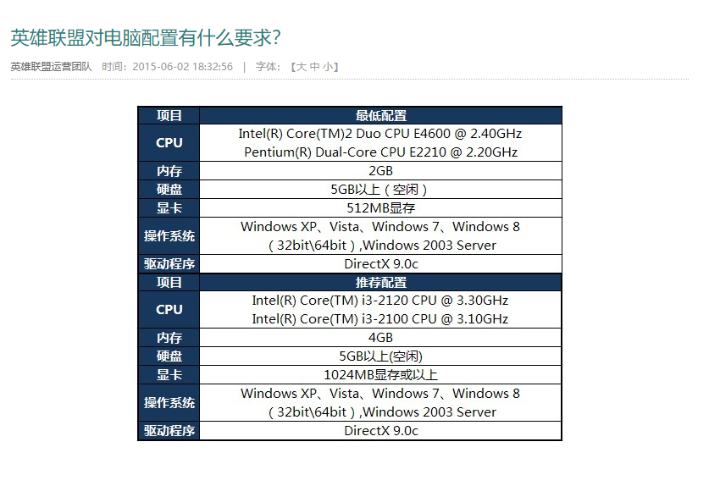

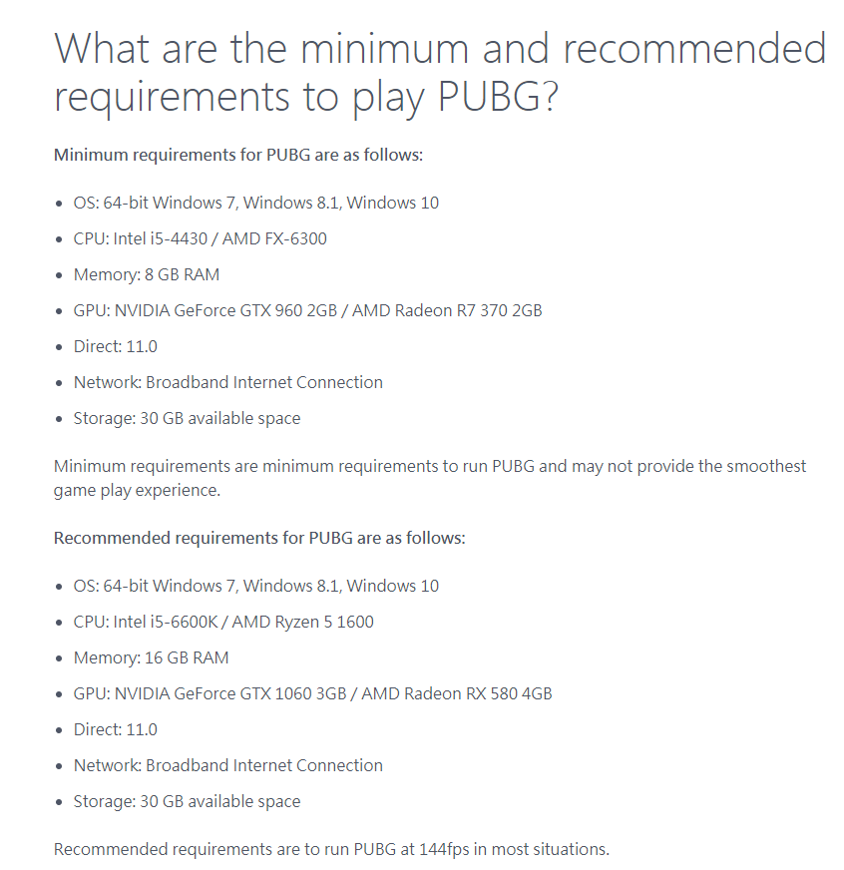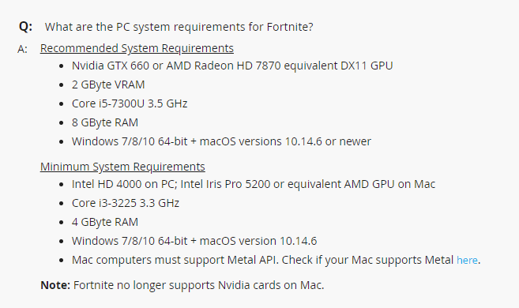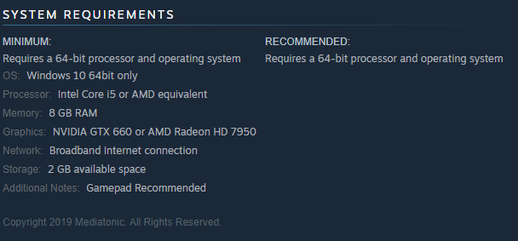

# Rules:

